**EXPERIMENT 2**

**AIM: Working with Docker (Basic Commands)**

**Steps to Complete:**

1. Search a Redis image on DockerHub  
   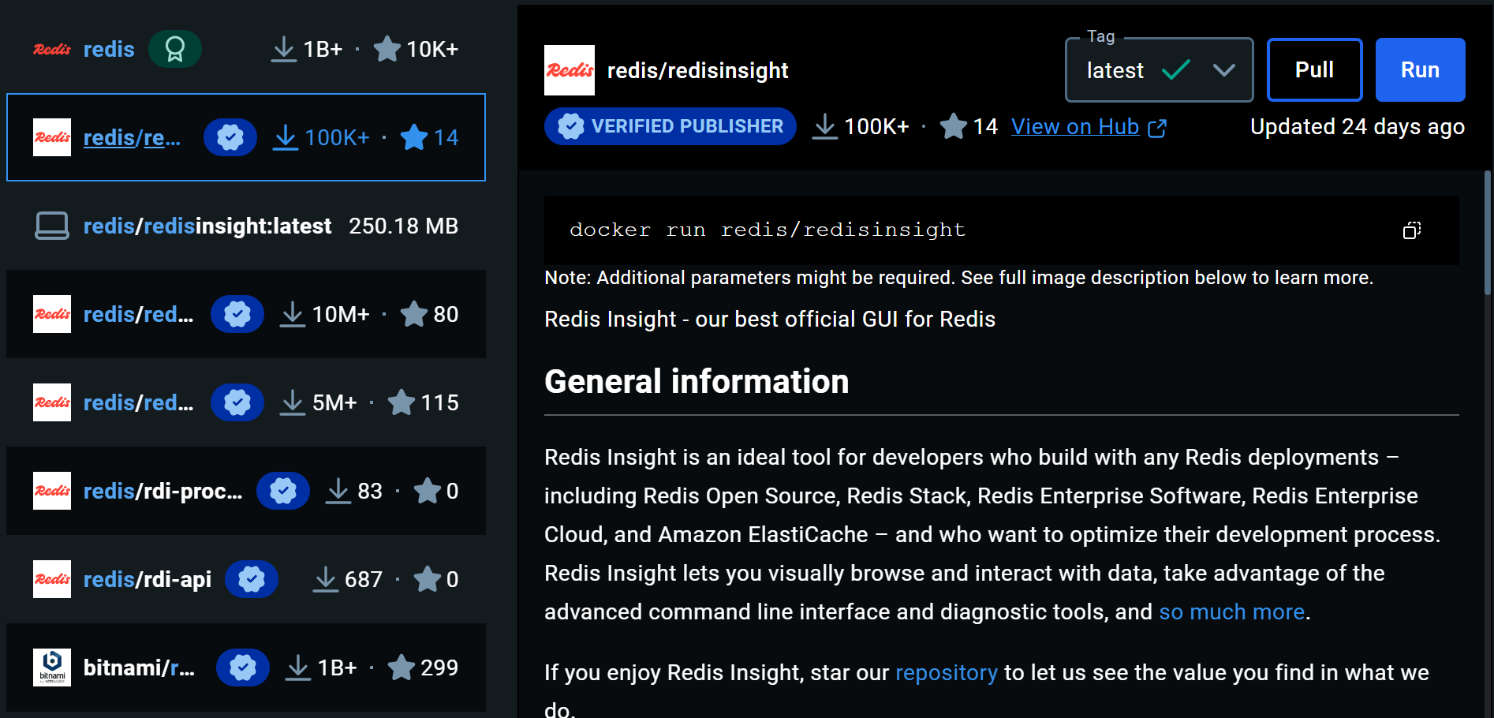  
   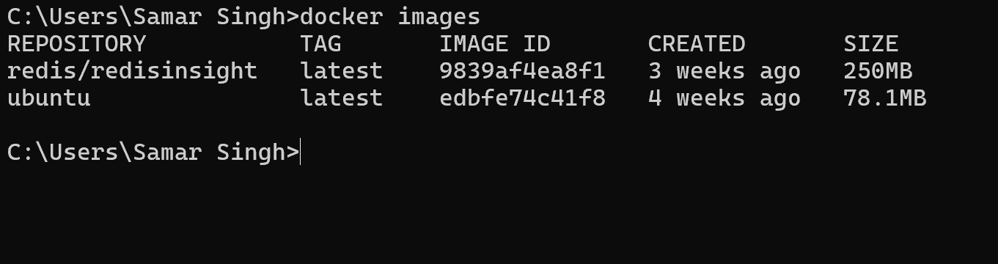
2. Run Docker Container of Redis Image in background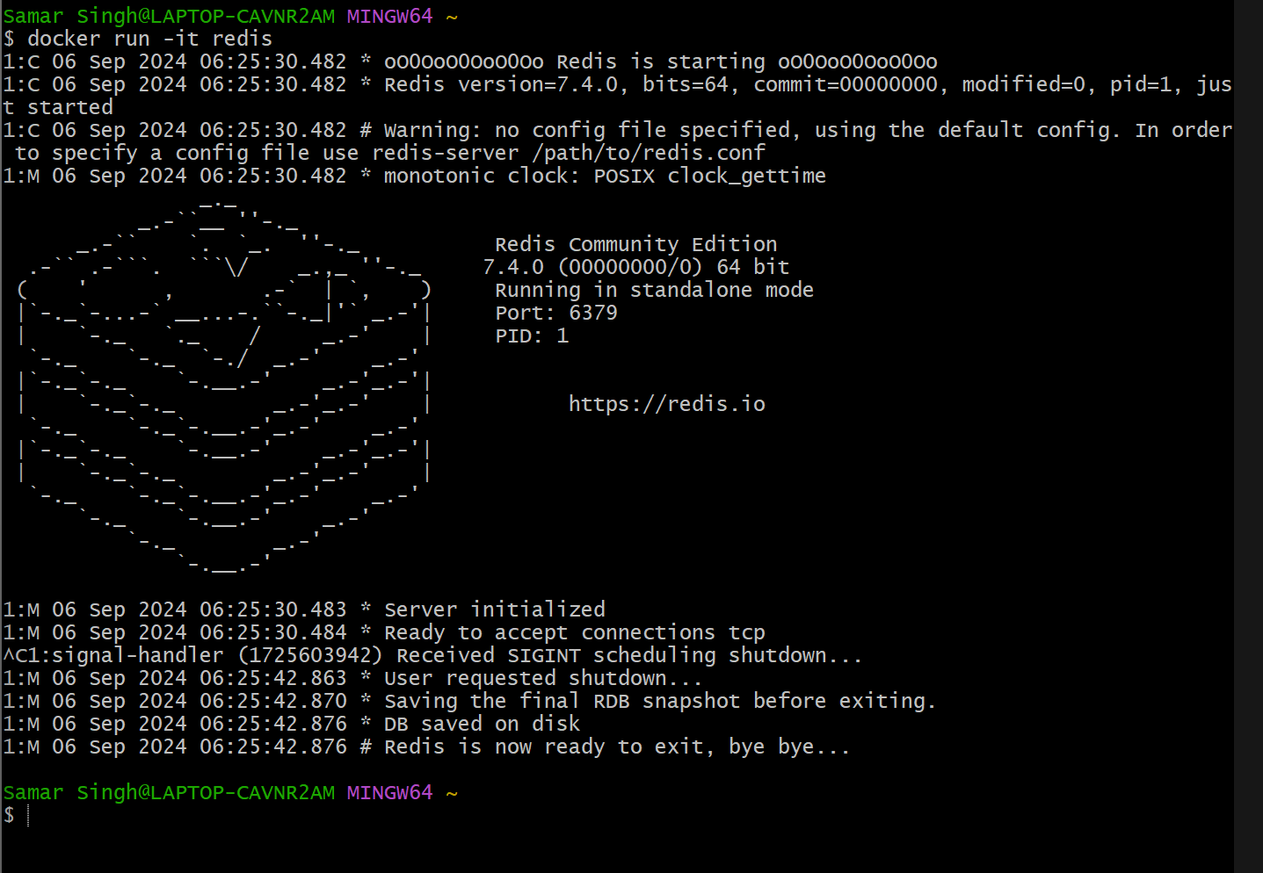  
   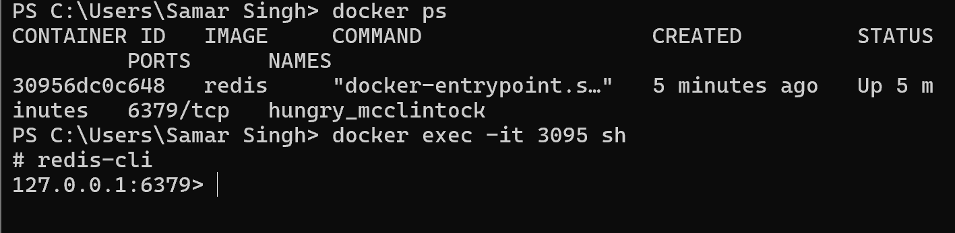3.Run Docker PS and Docker ps -a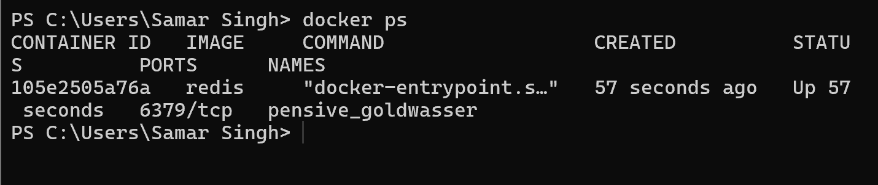  
     
   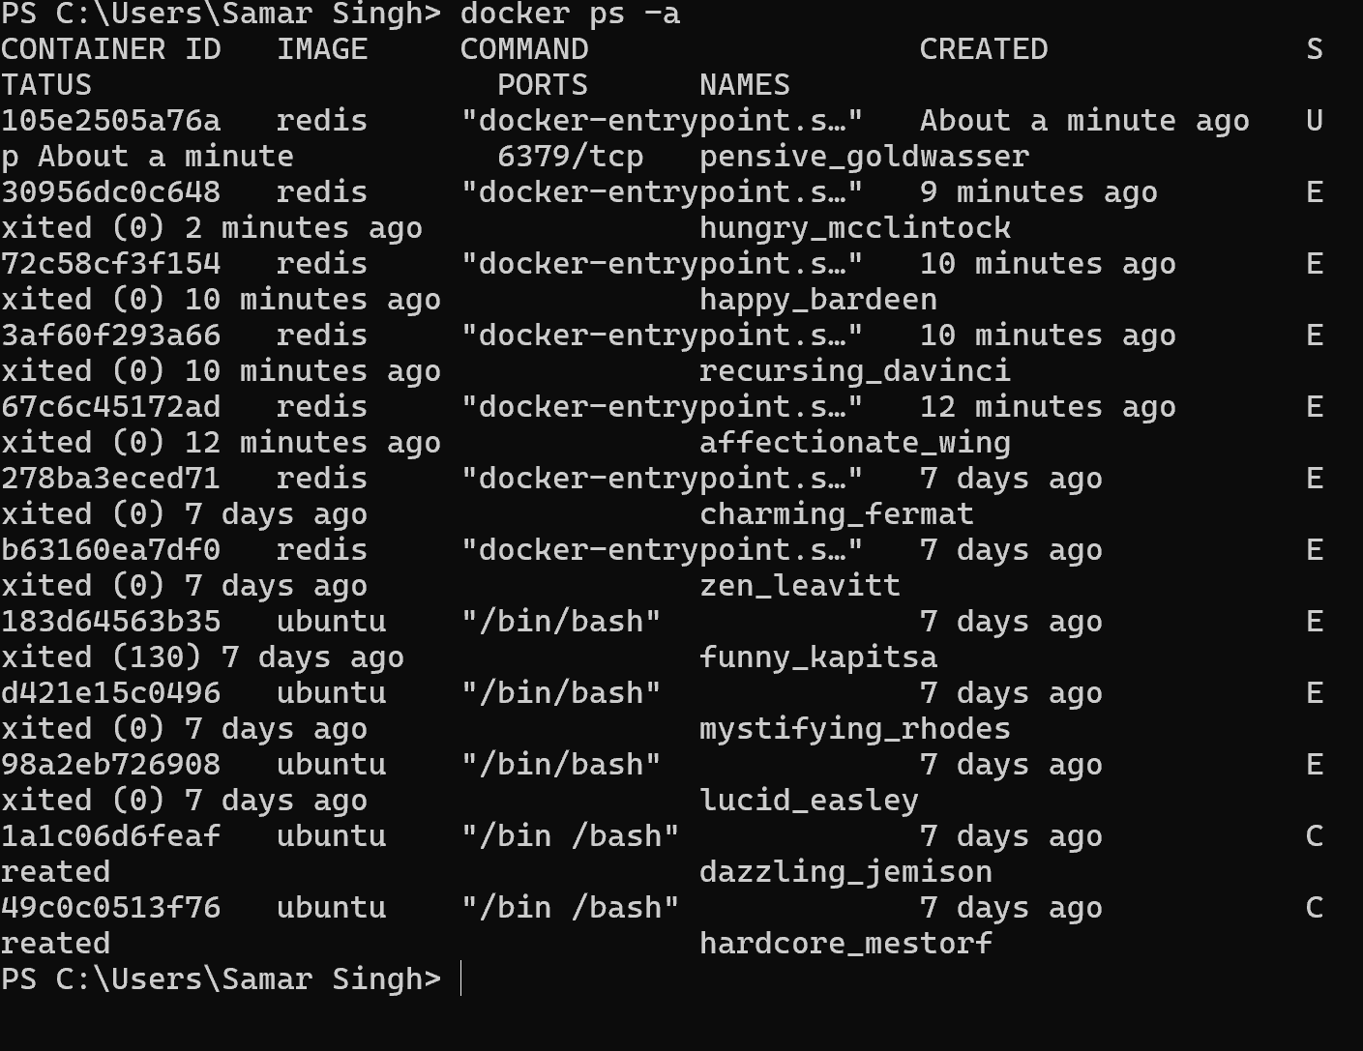
3. Run Docker Container and take its console 